hw #16

Re-read in your textbook about the Realist Movement in your textbook, and proceed to read about Cubism and the fathers of Cubism, the Spanish artist, Pablo Picasso and the French painter, Georges Braque. The Dove, is a type of composition that has some characteristics of paintings, but is a photo-montage, where actual photographs were cut out and pasted. Romare Bearden, a Harlem artist, clearly was influenced by Cubism. Cubism is a modern invention created by Pablo Picasso and Georges Braque. It is a style that is characterized by ambiguous space, multiple perspectives, and size distortion. Cezanne was the first painter to darken lines around objects simplifying and exaggerating everyday objects and landscape into cubes, cylinders, spheres, and cones. Picasso and Braque took that idea further. When examining The Dove for ambiguous space think of what you learned about what makes 3D illusion and how it is manipulated to create flat or ambiguous space here. Also, when thinking about Realism understand history and the relocation of black Americans here who had fled to Harlem away from the prejudice in rural southern states in hopes of building better lives in urban New York City.

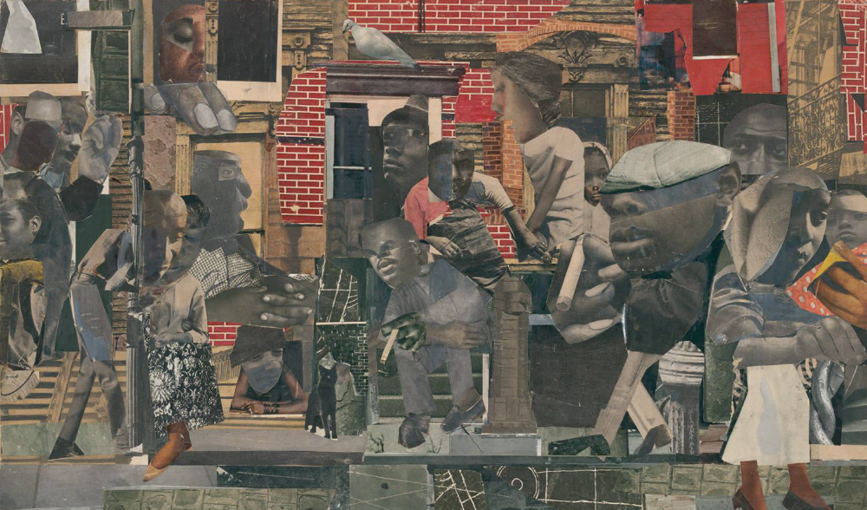
The Dove

